Exploding Colors

Requirements Documents

V1.0

introduction

Exploding Colors is a 2D matching game where the player has to match multiple tiles of the same features. It is s relaxing game which can also be challenging. The game is going to be about a board that has colors (or symbols) that must be matched together to increase one’s score. The board is going to be grid shaped with square tiles inside it.

Glossary

Player: is the individual who is playing the game.

Game: is the main class that control all elements in the program.

Board: is the container of tiles.

Tile: is the object the player must interact with.

Score: is what the player scored from playing the game.

Timer: is a clock to show how long the player have been playing.

Functional requirements

|  |
| --- |
| Start Game |
| Prerequisites: |
| Player at start page  Player did not start game |
| Steps:   1. Player clicks start button. 2. Game generate board. 3. a) Game generate tiles into board.   b) In case there are no matching tiles, game should recreate another set of tiles.   1. Timer starts counting. |

Picture 1

|  |
| --- |
| Restart Game |
| Prerequisites: |
| Player did start game  Player paused game |
| Steps:   1. player clicks restart to start new game. 2. Game creates new board. 3. Game fills board with tiles. 4. Timer resets to zero. |

Picture 3

|  |
| --- |
| Exit Game |
| Prerequisites: |
| Player paused game or  Player at Main Menu |
| Steps:   1. Click Main Menu to go to start page. 2. Click Exit to exit game. 3. Game closes.   Or:   1. Click Exit to exit game. 2. Game closes. |

Picture 1 and 3

|  |
| --- |
| Pause Game |
| Prerequisites: |
| Player did start game  Player is playing game |
| Steps:   1. Click pause button. 2. Timer stops counting. 3. Pause menu comes up. |

Picture 2

|  |
| --- |
| Match Tiles |
| Prerequisites: |
| Player did start game  Player is playing game. |
| Steps:   1. Player clicks on tile. 2. If there is match: 3. Tiles disappear. 4. New tiles come down. 5. Score increases.   If there is no match:   1. An incorrect move sound starts. |

Picture 2

|  |
| --- |
| Resume Game |
| Prerequisites: |
| Player did start game  Player paused game |
| Steps:   1. player clicks Resume. 2. Pause menu disappear. 3. Timer continue counting. |

Picture 3

Non-Functional requirements

Tiles should have minimum of five colors.

Game should display the Score.

Game should display the Time playing.

If the player beats the previous highest score, then the new score should be saved. If there is no previous score save the current one.

Matches can be of at least 4 blocks connected to each other from any side. They should be of the same color too.

For first 4 tiles the score increases by 10 each. For every extra tile the score multiplies by 1.5x.

If there are no matches on display the game ends.

The board dimensions should be changeable.

Tiles are generated at random.

Future enhancements

Multiple players (scores) and comparison of the higher score between them.

Ability to compare scores over the internet.

Sounds when clicking on buttons and tiles.

Changing the tiles to pictures.

Game modes (timed, or size of board).

Difficulty.

Music during gameplay.

Adding power tiles (with extra features like taking other colors with it).

Interface

Picture 1

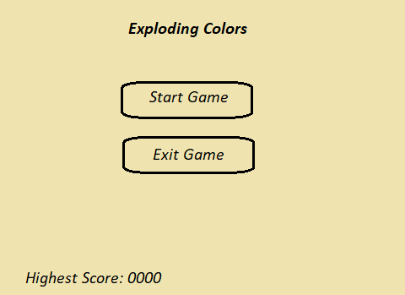

Picture 2

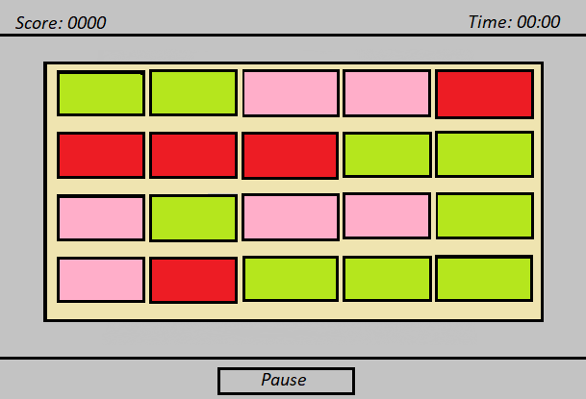

Picture 3

